Life Between Four Walls
Jesus Perez

Writing during this uncertain pandemic leaves a fresh open-minded perspective for thyself. These current events may leave other people shocked, surprised or in pure fear, yet I am taking this time to improve myself between these four walls. In the foreseeable future, people are reading about these past events in a history textbook as an unfortunate event, but life carries on. Yes, life will carry on outside these four walls when we are allowed to roam like we once did a few years back, but I will never forget this period of my life where I lived between these four walls. The tears, the laughs, the screaming and all the repetitive workouts I always forced myself to do for my health. The message here is it may not matter in the future, but I will always remember these events in my life, and I will cherish them dearly in my heart. It may seem like this time of my life feels unfair, but these events shall teach me the value of patience, health, and humanity. The following writing pieces depict these fun, sad, and angered times which makes me more human. Again, these writing pieces may not matter to those in the foreseeable future, but it is very significant to me.
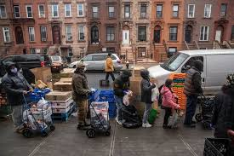

TOGETHER/APART
How are you staying connected during this time of social distancing?

In this time of social distancing, I am trying my best to stay connected by communicating with my friends through social media or quick phone calls on the phone. Social distancing is defined as staying 6 feet from another person, not gathering in big masses or groups, and avoid crowded places, according to the Center for Disease Control and Prevention. Even though this time of social distancing feels like a piece of my heart is melting away, I do find warm butterflies when I freely chat with friends through social media sites and Facetime chats in order to ignore all the over dramatized news outlets. I also have been fortunate to continue working my web developer job at the University Times remotely, allowing me to keep me busy with a thing I love to do which is programming. However, the biggest challenges with my job is difficulty finishing tasks on time, having a stricter deadline, and overall keeping a strict schedule at home to not fall behind on work. Other challenges include having quiet time inside my own home to take my midterms, exams, quizzes, or even writing thoughts in my head. From these challenges there are also less joyful moments during quarantine where I get frustrated for finding an ounce of peace, but I remind myself by staying indoors I am literally saving thousands of lives and it makes me feel more at ease. I do feel it getting easier by simply sticking with a good timed schedule on a daily basis, working out only in the mornings, reading a good book at least half an hour a day, programming for an adequate amount of time, and getting the homework out of the way before relaxing as I never had this amount of time to relax during the semester. I find it satisfying as I now have more freedom to do more productive tasks with the same amount of time I used to have during the semester; and I find the joy in this a lot as it leaves more time to relax for me.

Empty Places

I will want to have a Santa Monica Beach all to myself where I can meditate in solitude and hear the crashing waves hitting the grainy beach. Where the rays of sun lick my soul and taste the sun while running on the shoreline and letting the ocean massage my feet with each step. I will not have to hear the chatter, murmurings, or the monotone playful screams of other people on the beach. Simply being one with the ocean and grainy sand, feeling the ocean becoming a part of you like a droplet of water to a plant. Letting the beach take away all my problems, and even desires in this world because I will be consumed in the beach with its peaceful crashing waves on a sunny day. Soothing, soft, playful but powerful as the waves are provoking its assertiveness. I will lay on the grainy sand, hear the wind from the crashing waves, the playful seagull sounds, close my eyes and simply be in the moment. Letting the ocean be with me and me being with the ocean in peace.

Laughing at Coronavirus

People say laughter is the best medicine when an individual goes through hard times. I believe laughter is the best medicine even in hard, unclear, and uncertain times. I feel more at ease with myself after a good laugh and I feel a sense of hope rushes through my body like a majestic waterfall. It’s not a coping mechanism to ignore the fact of isolation, but a method to find the humanity in this world, to experience all emotions a person should feel on a daily basis. When I feel a little down myself, especially since quarantine started, I will go on YouTube to watch comedians such as “Gabriel Iglesias” or scroll through reddit for endless Coronavirus related memes. A personal favorite of mine is a programmer attending an online meeting, but he is only listening to the audio of the meeting. I find this meme extremely humorous as I relate to this meme a lot. I will do this with my own work meetings when I am not needed, I will walk around the house with my air pods and observe all the things I didn’t know I had laying around.

Infodemic

The claim that the “Coronavirus survives longer airborne and travels further in these public spaces — here’s where to be extra careful” from marketwatch.com is completely false, after I investigated it using the techniques suggested in Mike Caulfield’s “Infodemic” Blog. Yahoo, Flipboard, and Newstral have also stated the exact claim. Through a quick search index using google developer tools I found the real article and it is published by the reliable nature.com website on April 27, 2020. it states Coronavirus can have the potential to be airborne in public areas when people aren’t at least 6 feet apart from each other. Nature.com also states the research was conducted in Wuhan hospitals where the viral RNA is more concentrated due to social distancing being extremely challenging and concentrated ventilators are being in used. This claim is not applicable to public spaces where the common person is traveling for essential grocery runs or other essential places still opened to the public where a simulated environment is the same as a common hospital. The original claim is false. It should state specifically that an individual may have the potential to get infected airborne only in spaces where social distancing is challenging such as concentrated hospitals. This conveys false information to the reader of the listed websites because even the original reliable source says the keyword “potential”, meaning it is unlikely this can occur and if it can it may occur in highly concentrated hospitals where the research was conducted.

Heroic Act of Coronavirus

There I am, walking through the aisle of canned goods in the humongous packed Costco where everybody roamed to find scraps of food. I picked up the canned tuna from the shelf when the brim of my eye saw an old lady fall to the floor. I was about to rush to help her when a young girl, around my age, went to go help her to her feet again. I overheard the conversation the two exchanged and I heard the young girl decide to buy her groceries for today. At first, the lady refused, but the young girl insisted, and they went shopping for groceries together. I felt a spark in my heart for this heroic act, even though I didn’t commit it. A small act of helping an old lady from the ground to a bigger act of offering to shop for her and pay for groceries is truly kind. It made me feel there are people out there who want to help others in this quarantine, when most of us have little to offer. I believe there are a lot of people like the young girl and old lady on this earth which is something we should all follow as these kinds of acts are truly admirable under this quarantine phase of earth.

LIFE AS WE KNOW IT?

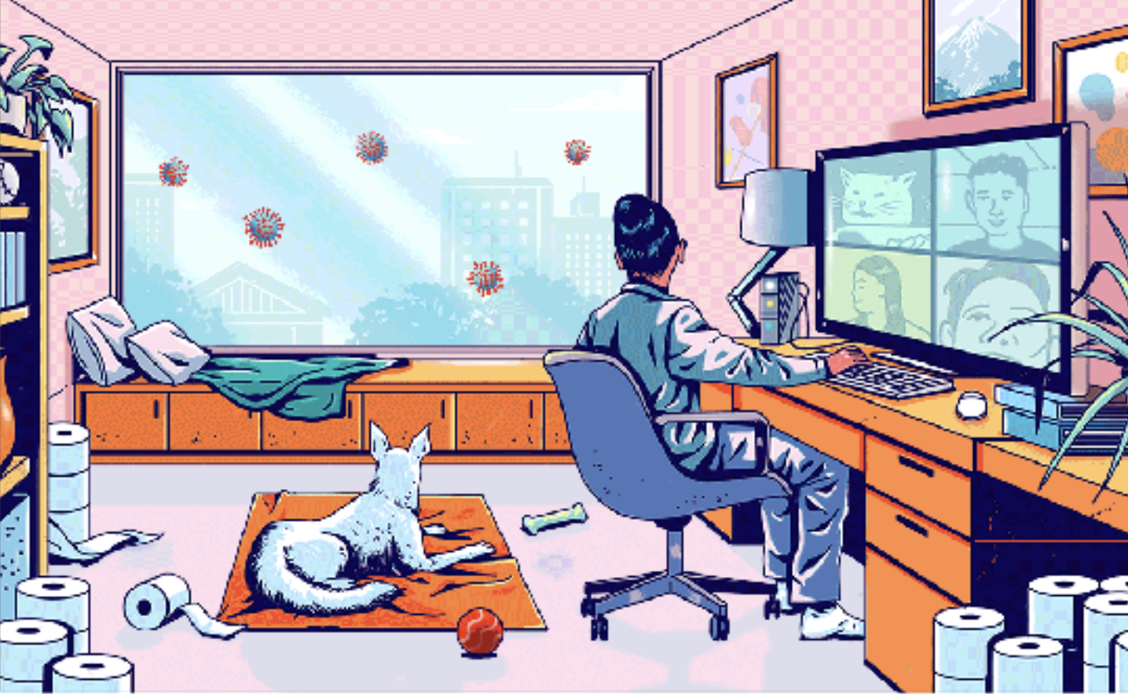

Counting all these toilet papers and hand sanitizers more than a thousand times, each time reminding myself I feel rich because I have the apocalyptic currency in my very own house. I usually count all my riches during my new attendance at Zoom University. One time when I was in my new virtual class I experienced something extremely “weird” and I will never forget it. I sat at my new virtual desk, discussing how Isaac Newton could discover Calculus in a similar pandemic while I’m over here thinking, “If I don’t give consent to Coronavirus, then it can’t enter my body” during my free time. Out of nowhere my ear instantly starts vibrating for mercy and everyone immediately started to freak out. I said, “What’s wrong, what happened? What happened?” I then realized the yelling was coming from the professor who was disciplining a student, who for anonymity purposes is named “Mike,” for what seems to be an orange cookbook with one word of profanity on it. The professor goes berserk about Mike’s cookbook which was being read by an older man in the background. Mike explains it’s his dad reading in the background; but the teacher persists with her remarks about professionalism and how profanity can lead to drugs. As soon as Mike’s dad hears this he too joins this blatant yelling match causing remarks which pierce your heart like a hot butter knife. Most of the students then decide to join Mike by putting up backgrounds of Shrek, White Cat, Sponge Bob’s house, and some even populate their screens with online memes like it’s free real estate. I sat there completely in shock yet wondering why I was missing one toilet paper roll from the shelf; I think my little niece decided to use it for a fort. I also started to wonder why they started to scream at Mike. Did I mention earlier that dayI texted Mike to see if he received the cookbook I sent him for his birthday since I couldn’t see him in person due to quarantine.

Play It Out Loud

I am listening to a blend of melancholy acoustic, catchy rock, and upbeat pop songs during this dark quarantine period in life. Types of songs I can’t describe in one genre, but a genre best described as heart soothers. The real genre is called “Folk” or “Indie,” which is subjective for these types of songs, but the real meaning of these songs is talking about life’s deepest emotions in love and in general. A great artist singing these types of songs about deep personal messages is an artist going by the name “Passenger.” A great song I’ve listened recently is named “Scare away the dark” which isn’t popular like his well-known song “Let Her Go.” “Scare Away the Dark” conveys the meaning of what a technology free world will feel like, where we don’t care about hashtags or twitter tweets or those annoying digital advertising popping up on YouTube screens. It also explains one’s own personal experience on social media, and the comparison of one’s own happiness to the happiness of social media influencers when in reality we’re all a little sad deep down when we make this sort of comparison. This is extremely important during these times when people are scrolling mindlessly on social media. From the line “We wish our weekdays away, spend our weekends in bed” to the line “And all just because that’s what mom and dad said we should do” is extremely a powerful eye-opener for most of us during this quarantine; it’s the exact realization I see on all these social media websites. I, having a strong social media presence, and I get caught up in this fake life from time to time, but I remind myself it isn’t the definition of myself. I do believe it is an ironic song to taste the bittersweet melancholy sensation in one’s own soul, but the song also explains our freedom of choice and to not take advantage of it in any moment of our sprinting life. I strongly trust my own gut, it’s what a lot of people are realizing under these moments of uncertainty as they are reflecting on the meaning of life. We’re judging whether we want to live a life based on fulfillment, doing something we love to do on a daily basis or if one’s own soul realizes they’re on a never-ending treadmill trying to catch a piece of whatever it is in life. This is extremely important when a lot of people are mindlessly scrolling through Instagram, blowing up their TV with irrational news, or the mind draining complaints of people saying “this quarantine is terrible for our mental health.” Rather than seeing it as a period of uncertainty and darkness, most people should see it as a time to reflect and stop judging other people and feel empowered knowing they have choice in life. These are the feelings of certainty back into my own heart where I feel safe and secure under these times of uncertainty and darkness. I acknowledge the feeling and I do anything in my own self-control as possible to live a fulfilling life. To end with, a favorite line from this song, and my favorite verse of this artist, is the following: “Love without fear in your heart, Feel, feel like you still have a choice. If we all light up, we can scare away the dark.”

Coronavirus Haikus

Corona Virus

Is it in the air?
Or is it between my toes?
CoronaVirus.

Between These Four Walls

Everything is Done
from these four walls and it is
Really boring

Washing Hands

Wash with super soap
Gets the little viruses
Away from yourself

