Freedom Within a Quarantined Life
Daniela Alvarez-Orozco

Keep a notebook. Travel with it, eat with it, sleep with it. Slap into it every stray thought that flutters up into your brain. Cheap paper is less perishable than gray matter. And lead pencil markings live beyond memory. —Jack London

When writing I feel pressure being released after holding in all my thoughts throughout the day. Having the chance to write about different topics was almost like exercising my mind. These topics really made me think about stuff in a way that I haven’t before. Having these prompts every few times a week was refreshing, especially after being home and not having much interaction with other people and friends on a day-to-day basis. Not only does my writing help me, but it also helps people my age in the future, especially if they find themselves in the same situation in the future. My writing may help them relate to what I was going through or can take what I’ve said in my writing as advice for what to do during a pandemic/quarantine. Writing during this pandemic about my experiences is almost empowering because I’m writing my own history during this pandemic that I can look back at when I am older and remember a memory that has been written down. During the 2020 Coronavirus pandemic through the act of writing my story, my voice is captured and heard.

Together/Apart

Social distancing is keeping away from large crowds in order to keep the virus from spreading. The greatest challenge has been trying to stay positive while being home all the time where it’s a little dark. Being able to see a nice day and wanting to go for a walk on the beach sounds appealing, but it is something that isn’t recommended to do at the time. I think isolating myself has given me a chance to learn how to be on my own and focus a lot on school. I stay connected with family because I see them every day and we always talk to each other. I stay connected with friends through social media, but it does get lonely without seeing my friends. I think it’s getting frustrating not being able to see friends and loved ones and be able to go out for a while just for fun. On a good note I am getting better at organizing and completing schoolwork.

Empty Spaces: My Own Space
During these tough times many locations are closed, and people are told to stay home as much as possible. During this time, I am having a mixture of feelings of being lonely and not having enough time alone. I am lonely because I do not have the company of my old roommates whom I became extremely close with or my boyfriend whom I haven’t seen once since this quarantine started. On the other hand, I don’t get enough time alone because I am home all day in a house with my two siblings and my parents, and I don’t have my own room where I can rest and reflect on my own. With all that said, I think I would like to have a big space where I could do my arts and crafts and also have a specific space to rest. So basically, I would enjoy a nice room / house to myself fully furnished and decorated to my liking and to have my favorite foods stocked in the kitchen. To me there’s something peaceful about having my own private space where I can do what I want to do without having to share that space with anyone else. I would want an art studio on the second floor of this imaginary home which would overlook a nice view. I would like a room where I can do projects with fabric like sewing and embroidery. I would like this home to have a comfy area where I could watch videos and movies. I would prefer if this house was a mile away from the next house so I could have privacy. This house will also include a pool and a big back yard with big trees so I could hang a hammock. This home will be my safe space. I thought about being alone in an amusement park or a mall, but I would ideally like to go to those places with my friends and family, unlike Sky Zone where I could just jump around and be a kid again.

Cue the Music
During this quarantine we lack human interaction and there isn’t much we can do at the moment. The only things we can really do is try to do homework to our best ability, catch up on tv shows or movies we haven’t seen, and listen to music. I personally try to find new music to listen to or find older music in which I haven’t listened to in a while. Music has become a big part of my life during this quarantine. Music has created a sense of belonging by triggering different emotions in me that I wouldn’t get from just being home. Music reminds me that I am human and that I need to be stimulated in some way. Music reminds me to be happy, confident, goofy, relaxed and sometimes even sad- and that is okay. During this pandemic I have been trying to find music that makes me want to dance or just puts me in a good mood. The reason for that is because I’m in my house 24/7 and it really puts a toll on me and makes me really upset because I don’t see my friends anymore, I don’t go outside, and I don’t dress up or get ready which puts a toll on my confidence. Listening to upbeat music helps me stay in a positive mood which helps me get through the day. A song that I have been listening to lately has been Move Your Feet by Junior Senior. This song has really been putting me in a good mood especially when I get ready to get groceries with my dad. I have been listening to different genres and some artists that I’ve been listening to are Tyler the Creator, David Bowie, The Weeknd, Harry Styles, and Dua Lipa, It’s not just those artist but I try to listen to party music or music that just makes me want to dance. I think that having that feeling of happiness is really important to have right now because it keeps you from being down. When looking for a song that I like I tend to really pay more attention to the beat because the beat usually makes me feel certain ways if its happy or sad, I tend to focus a lot on the beat. Once I like the beat, I’ll listen to the lyrics next and fall more in love with the song. I also have been trying to find a lot of old Spanish music that I would hear as a kid when my mom would start mopping because that music brings me so much joy.

Promt: Infodemic

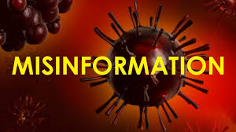
During this epidemic there is fear running through everybody’s minds. People search online in panic to find information that can possibly help them avoid this virus. I am also scared of this virus, but I always make sure to watch the news for updates and make sure to have good hygiene and follow the social distancing rules. Since I spend a lot of my time at home, I end up scrolling through social media to distract myself and that’s where I found a post talking about how the president recommended people to inject disinfectant into themselves or drink bleach. This caught my attention because it was the president saying these things. Luckily, I knew that it wasn’t believable because those chemicals are poisonous to the human body. This false information is extremely harmful because there are people who are terrified and desperate to make sure they stay healthy and people will actually try this especially because it came from the president’s mouth. This information is extremely harmful because people will try this and become really sick due to this and can even die due to his reckless words. I this is false information causes concern because it came from the president who is supposed to be giving good advice and useful information to help out the people instead of giving them false information. Luckily as seen on The New York Times the W.H.O is taking action in making sure they share a page of coronavirus “mythbusters” on different social media platforms where people are seeing the most false information so hopefully people see post from the W.H.O page which gives them the correct information.

Life as We Know It
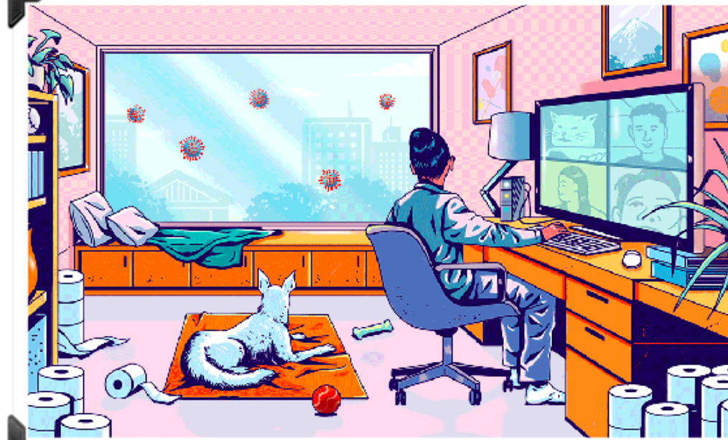
Life as we know it has become overrun by a virus that has struck fear in many people forcing everyone to distance themselves socially to avoid getting sick. People hoard daily necessities which leaves others with very few supplies. Luckily my dad and I have made many journeys to Costco and Smart & Final and managed to score some toilet paper. I’m in a family of five, six if you count my dog Fido. Almost every day I am left to fend for myself at home just me, my older brother Esteban, and my dog Fido. My mom and dad are superheroes, they fight against the virus every day and make sure to keep the environment clean. They are gardeners. My parents aren’t the only superheroes, but my sister is also a superhero. My sister protects those vulnerable to the virus; her super suit is scrubs. My sister is a nurse. Life has become a lot harder since quarantine started my brother and I have become guardians of our home. Every day we make sure our home is in tip top shape and nothing dangerous enter our home. Just because the quarantine started doesn’t mean that my education stops. On most days I have virtual meetings with super professors that pass the students’ knowledge. I can feel my brain absorbing everything that I learned. After going over all my lessons I have some spare time to myself and meet up with all my partners in crime: Janely, Litzy, Chris and Edson. They are also guardians of their homes. We all used to live together before this quarantine, but had to go our separate ways once this law was made. Now, we talk through Facetime and make sure we have a plan of action if this virus ever tries to enter our homes. As you can see above, Litzy’s cat always wants to say hello on Zoom while were in a meeting. We all have different powers and my ability is to see the virus physically as you can see in the picture. I tell my parents and my sister when it’s clear to exit the house. There is always one person in a family that has this ability, and I happen
to be that person. My brother’s ability is strength. His job is to fight off the viruses before they try to come in. All my friends in which I have meetings with have the same ability as me and we share different experiences to make each other stronger that way we know how to stay safe. My sister is a healer she makes sure that those who are vulnerable stay strong enough to fight off the virus if and when it comes. My parents have all the powers combined which is why they are able to be outdoors and continue doing what they’re doing. They’re the strongest people I know. I spend my days at home making sure I keep our home clean so they can get home and rest, especially after spending the entire day fighting off the virus and making the environment a much healthier and more beautiful place. I also train with my brother at night by playing Call of Duty to make our reflexes are much sharper to keep our family safe. We work as a team every day. Did I mention that my dog also helps out by warning me when the virus is near? Our powers aren’t just for the virus, but are applied to everyday life- however, they really do help us during this quarantine. I don’t know how many days have passed since I haven’t been keeping count. Something that I am sure of, we are all safe as a team and none of us have been attacked or taken over by this villain we call Coronavirus.

HAHA’s During Quarantine
During this quarantine it is hard to stay in a good state of mind. Sometimes being home is preferred by some people, but once you are forced to stay home and not go out, it gets difficult. Being home all the time makes you feel like you are going crazy. Sometime making light of the situation is all that we can do to keep our heads up. Having a good laugh about the virus is okay. Laughing at the situation that were all is better than moping around and having it keep us from moving forward. It is a lot better to laugh at a few memes about the virus and have a good time and continue on with your day instead of letting it ruin your day. Something funny that happened was the funny interactions that I’ve had during Zoom meeting in class. Once, during a meeting for Spanish class my Spanish teacher made fun of huge pictures that hung in the living room of my sister and I in our Quinceñera dresses. It was embarrassing, but it was also funny because the rest of the class laughed. Being able to see the light in situations is nice and relieving.

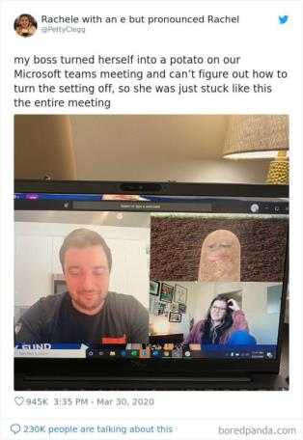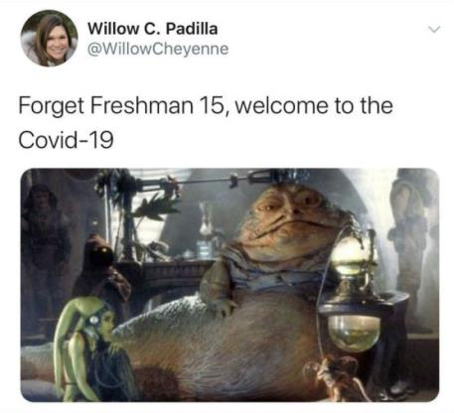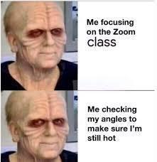

Haiku

Sleep schedule messed up
Deprived of all my friends love
Need vitamin D

Gaining so much weight
Can’t find clothes that fits just right
Mom says I am fat

Need sunshine and trees
I would like some ocean breeze
Sunset and repeat

