A Battle Far from Unique
Caleb Rodriguez

What if I told you that we were at war? A war so unpredictable you don’t even know when you are going to be attacked. COVID-19 is exactly that; it is an ongoing battle that is full of uncertainty, waiting to ambush us when we least expect it. However, just like any war, we have those that fight for their brothers in arms, those who try to do what they must do, and then those who are unfit. This battle has only begun, many seem to believe it is over, but something like this doesn’t end so quickly. This battle has shown us all that there is much to be worked on. As I stay at home and do the minimal as to what I must do, I have come to the realization via videos, and articles that we humans can be extremely smart, but also extremely stupid. This collection of ‘stories’ if you will, will demonstrate my story. A story extremely far from unique, seeing as a lot of people at this moment are going through what I'm going through. This battle that we are in is not the first, nor will it be that last, so get ready for a bumpy ride.

Together/Apart
The Covid-19 outbreak is something big affecting something bigger, or that’s how I see it. Students already have a variety of things going on in life. So, with the addition of this outbreak, it has become a little frustrating for students. Unfortunately, due to this outbreak, people have lost their lives; people have lost love ones. Also, there is no doubt that among the victims of this adversity, there are young students. This added weight is not healthy for students, especially those who already find school extremely stressful. So far, I have done fine, but this added weight has enabled some bad habits, such as procrastination, and now I must deal with the impact everything all at once. Unfortunate circumstances.

Empty Cities
As humans, we have this innate ability to create amazing things that are filled with complexity. Rather than want an amusement park all to myself, I’d like an entire city. I have always had this deep fascination for cities, and I think it is something that I will never outgrow . The ability to explore some of the most fascinating cities in the world is something I would not think twice about. However, I want to expand on this notion of finding cities fascinating since I feel it will make this a lot more believable (instead of writing something just for the credit). Ever since I was introduced to a rather simple game called Minecraft, I have had the ability to just build to my heart is content, as if playing Lego, but virtually and never-ending. I spend hundreds of hours building. This deep love and fascination for the creation of building houses and cities is something that I believe will never leave my side. Therefore, I would want entire cities to be empty spaces so that I can explore the various intricacies that hold them up. Some of the cities I’d like to explore are Tokyo, Japan with its stacking buildings all over the place and Mexico City, Mexico, a city built on top of a lake.

Life as We Know It

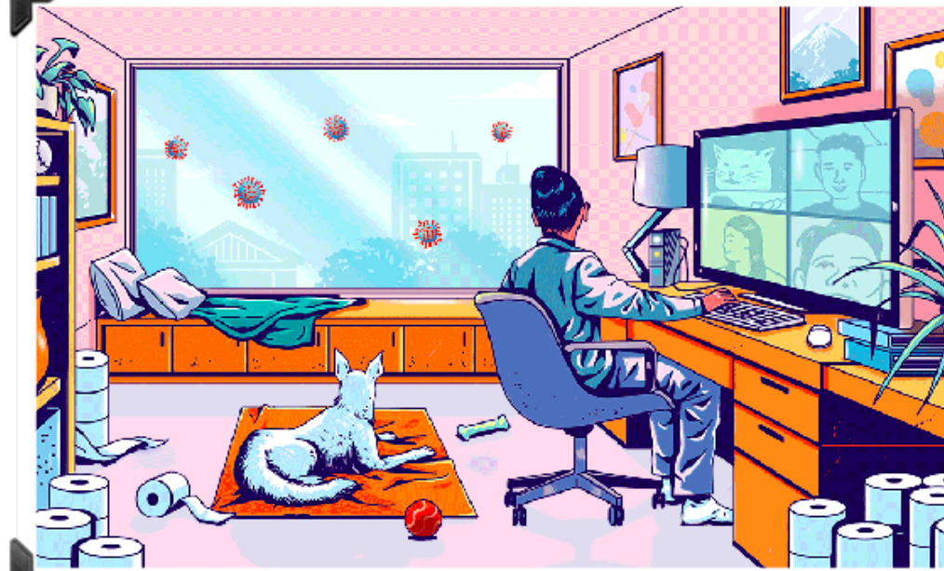
We want to go outside! But we CAN’T!

It is 12 pm, surrounded by an enemy that is invisible and can attack any time without warning. The only way to combat it is by staying home and isolating yourself with people you care for. Uncertainty is quite the crook. Luck struck you if you live with family, and boredom is alleviated just a bit. You sit and start typing away at your computer, one of few sources of communication you have with friends or loved ones. Boredom is alleviated once more. Your dog sits behind you and stares out the window, almost reminiscing about the countless walk you took him out for. You start to imagine, “what if they could walk and attack us like zombies?” Your weapon of choice, ‘toilet paper’ the new AK-47, durable and soft. Indestructible. You laugh. Boredom is alleviated once more. You turn and look out the window. You realize that boredom is going to hit you hard once again. Uncertainty is quite the crook.

HAHAHA, I Think this is FUNNY! Laugh with me!
One day I was sitting down on a plastic chair, minding my own business watching something on my computer—I don’t remember what. As I was minding my own business, the chair I was sitting on decided that I was a little too heavy and snapped. Unfortunately, my left leg was right under the chair and I landed right smack on top of my ankle; it was extremely painful. As I managed to fix myself into a less painful position, I looked at my ankle as it slowly rose; it seemed like a virus took over my leg—as if I was infected by a zombie in the Walking Dead. My ankle slowly became purple. As everything calmed down, I started laughing so hard while letting out vulgarities. To me, it was the funniest thing to have happened to me for a solid while. Laughing allowed me to calm myself down, for all I know, a piece of the chair could have stuck itself into me. So, laughing made me relax, it let me come to terms with the fact that I could've just been impaled by a chair, funnily enough. I believe it’s the same with this whole COVID19 situation. Laughter allows for people to understand that something like this is inevitable. It provides us with a little haven until the walls start crumbling around you and then you might not find it funny. Laughter is not the best medicine, but when that’s all you have, it'll work wonders.

Haiku

Woof

Woof? Where is my walk?
Human? What is going on?
Uncertainty crook?

Doubt? Please don’t

I can not see it.
Where? Invisible killer?
Where? I can’t see it.

Big NOSE! I say walks are a HUMAN RIGHT!

Quit with the lies…lies?
Look at my nose! It’s big!
We can WALK! NO LIES!

