Untitled
Anonymous

You may not write well everyday, but you can always edit a bad page. You can’t edit a blank page. —Jodi Picoult

Before this whole pandemic happened I feel like I took things for granted such as not going out with my friends when they would invite me places and not hugging people because I did not like the idea of a “hug.” Now that my family and I have been self isolating ourselves I feel like everyone needs that feelings of comfort. Don't get me wrong, my family does give me the feeling of comfort, but I just feel as human beings we need to be around people and socialize. A way that I am making my voice be heard during this pandemic is through social media because right now everyone is on it. I'm always trying to connect with people and make them hear my point of view; though they might think differently, I am making my voice heard. During this pandemic I found a voice that was too scared to bring out before because I wanted people to like it. It is ad that it took me this long to actually find my voice. Thus, through the act of writing I was able to find my voice during this pandemic.

Together Apart

Social distancing means keeping space between yourself and other people outside of your home. During this time my family and I are practicing social distancing by not sitting so close to each other when we are on the couch. We also wash our hands the most we can and we also have a lot of hand sanitizer nearby just in case we are not able to wash our hands. We're keeping our hands out of our eyes, nose, and mouth. The greatest challenges that we have faced during this time might be the fact that we can not go out. And if we do go we have to wear masks and gloves at all times. Something that I enjoy from social distancing is that people do not get so close to me because I do not like when people get too close to me. Another joy is that we are keeping others safe. A few ways that I am connected to my friends are through Facetime and other apps or websites where we can share a screen and watch movies together. With my family we have been talking more than usual. We are getting to know each other a bit more which I enjoy very much. For me living in isolation is getting a bit easier because I enjoy it at times, but there are also times when I can’t be inside the house for too long because I get anxiety attacks.

Empty Spaces

As I was going through the article “The Great Empty” and looking at some powerful images, I came across this one image of a woman and a man basically sitting alone looking forward into the city of Hong Kong. As I thought of a place that I could have all to myself, the Hollywood Bowl came to mind. The Hollywood Bowl has a glorious view of downtown from right on top of the amphitheater. This place came to mind because it is very peaceful, and during the night the city of Los Angeles can be seen for miles. The lights from the buildings and street make the scenery even more beautiful and breathtaking. I feel like the up to actually see the whole city really makes a difference because the hike makes us clear our mind. In my opinion I think it would be a great way to help someone who might be suffering from anxiety.

Infodemic

One bit of false information I heard about the Coronavirus was from our very own President. He stated that injecting yourself with disinfecting will defeat the virus. I found this information from the news because they were warning people not to do what the President was telling people to do. This attracted me because I know that there are many people who might not be aware that it actually is bad for them and they might go around doing it. They might think that injecting themselves with disinfecting products is going to help. To some people this might feel believable because it comes from our so-called leader. I personally didn't believe it at all. This type of information is harmful because people are going to start doing it and they are going to end in the hospital, and at the moment I don't think we need more people admitted into the hospital. This would be harmful to people that truly believe that that's going to help them. I do believe that this false information can create panic. In the article “ W.H.O Fights a Pandemic Besides Coronavirus: An ‘Infodemic’ ” by Matt Richtel, he states that Aleksandra Kuzmanovic sent out an email to Pinterest to share pictures and images to show make people aware about misinformation. “She emailed a contact at Pinterest, the image- sharing social media giant based here in San Francisco, to ask if the site could help the W.H.O. combat the blazing spread of misinformation, lies and rumors about the new virus.”

Play It Loud

I don't believe that this pandemic has affected the music that I am seeking or listening to at the moment. As a matter of fact I haven't been listening to a lot of music lately because I've been watching a lot of Netflix and doing homework of course. I'm starting to listen to music I use to listen to back in middle school mainly because I found out the group was getting back together and I’m mentally preparing myself. The music I've been listening to or playing recently is pop rock (Harry Styles). I am a very emotional person so a lot of songs make me cry even if they are happy. I think they make me cry because I listen or focus on the lyrics and it moves me. A song that is important to me right now would be “Falling” by Harry Styles. I feel like music can affect how we experience painful or difficult moments in life because the lyrics could hit you differently when you're going through hard times. What I think makes lyrics good or powerful is probably when the songwriter is writing them it makes them feel some type of way and sometimes the lyrics could be meaningful to them in some way. Other things I listen for in a song is the beat. If a song has a good beat I could listen to the song for hours and not focus on the lyrics because sometimes I do zone out and the lyrics do fade away, and all that is left is the beat.

Life as We Know It

Life as we know it. Something in my current life that makes me think of the first image is all the schooling we have to do everyday. It also makes me think about me communicating with my friends via Facetime or sometimes we do our own little meetings on Zoom which most of the time we use to share each other's screen to watch movies or videos. I feel like I relate to this image the most because most of the time I am home in pjs and my hair is always up and I'm always on the computer. I noticed that the girl in the image was looking out towards her window. I feel like I relate to her because there are times during that day where I find myself staring outside. I feel like I don’t notice when I do it mainly because I get easily distracted and zone off. My cat is always behind me bothering and trying to scratch everyone in the house since she's old and most of all her teeth have fallen out.

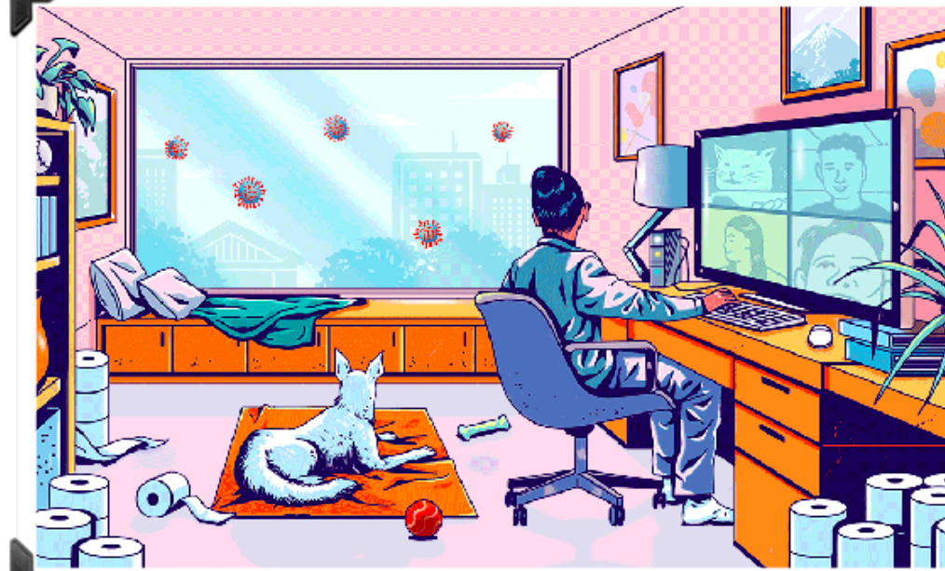

Prompt Ha Ha!

When I googled why laughter is the best medicine it stated that laughter decreases stress hormones and increases immune cells infection fighting antibodies, thus improving resistance to disease. In my own experience I kinda do see it as true because when my siblings and I laugh we don't think about all the things that are going on in the outside world. I feel like making fun of each other makes these difficult times better. For me I do feel like humor is a coping mechanism because I am anxious all the time and I feel like laughing helps me become calmer. At times I do see myself laughing at Coronavirus-related memes because some of them are funny; they do not always joke about all the deaths that it has caused.

Haiku COVID style

An afternoon breeze
Expels cold air, along with
The fallen brown leaves.

I feel the fresh air
In the cool crisp morning sun
See the pretty leaves.

Trees leaf in springtime,
Provides shade of summertime
Weather culminates.

