Inside of Pandemic
Claudia Lara

Never forget that writing is as close as we get to keeping a hold on the thousand and one things—childhood, certainties, cities, doubts, dreams, instants, phrases, parents, loves—that go one slipping, like sand, through our fingers. —Salman Rushdie

During these difficult times of this pandemic, writing has allowed me to express myself in ways that I was not able to in person. In a difficult time like right now where the Coronavirus has taken over the world, it is important to write down all my thoughts. I truly feel that by writing I can make a difference in the future when someone reads my work. By writing all my thoughts down it has allowed me to feel better about myself and the situation going on. It has made me take my scary thoughts out of my head into words on a computer. Although I used to not like to write much, I have realized that it is a big factor in my life as it makes me feel like I have control over something when writing it down.

The Never-Ending Pandemic

Staying connected during this hard time where the whole world has to practice social distancing is not very difficult, but it could get lonely at times. Social distancing is having to have less face to face communication with others, especially during this difficult time due to the Coronavirus. The way I have been practicing my social distancing is by trying my hardest to limit myself from going out. By doing so I have been ordering anything I need through the internet; the only things I have been going out for is groceries like meat or chicken. Staying home all day has become difficult as the days go by; I feel like I have officially binge watched every show on Netflix and feel like I am running out of things to do. Before the outbreak of Covid-19 I was always out with friends, family, my boyfriend, or simply running errands. So, it was certainly very difficult to just stay home and do all my school learning from home. I feel like the only unexpected joy I have since we had to start social distancing was in the very beginning when I felt very happy because I got a small break from school and work. I try my best every day to stay connected with my family and friends everyday by talking to them through my phone and video chatting. As much as I try to not go out as much I do go to my boyfriend’s house once in a while just so I can have a change of scenery and not feel like I’m going out of my mind. As the days go by, I truly do feel like it is getting a lot more difficult to stay isolated because I was just so used to staying active. It sucks how we get bumps in the road like the Coronavirus because it canceled my trip to Mexico. The way I feel like we will all get through this is by just staying positive because there will be light at the end of the tunnel.


Only in My Dreams

I always wondered how it would feel to have Cancun all to myself with my special person. Cancun is just a peaceful place to be and I always wonder how it would feel to actually relax and not hear other people talking. Cancun has so many beautiful places to visit and also have so many amazing activities that could cause long lines to many attractions. I would not like to be the only person there because it would seem lonely, but I would not mind just a few people, so the lines do not get crazy. I would love to experience Cancun that way so I can get to do what I would love to do in a couple of days. I would also just love to some peace and quiet while listening to the ocean waves crash.
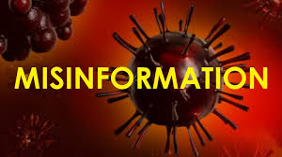

Not True

The outbreak of Covid-19 is causing so many people throughout the world to panic. I have read throughout social media that alcohol can prevent and maybe even cure the Coronavirus. It is a very interesting idea because and could make sense to some; since alcohol can kill germs outside your body, maybe drinking alcohol can prevent us from getting the virus. I would believe this like many other people, but would be always sketchy as it cannot be great for someone’s health. This false information is very harmful to those who actually believe it because they will consume alcohol and could kill themselves. This is definitely a money-making scheme as it causes people to do an impulsive buy and make money to those companies. According to an article in Newsweek.com, it says alcohol cannot cure the Coronavirus and can actually kill you. They stopped the rumors by an organization called World Health Organization, who stated “spraying alcohol or chlorine on the body will not kill viruses that have already entered it and that spraying such substances can be harmful to clothes or mucous membranes. All these theories about how to cure Covid-19 are dangerous as they can actually harm a life instead of help it.

Living in a Music Note

Music for me has always been like another friend I can go to, especially during this time of social distancing; music has made me feel happier and less lonely. I feel like I still listen to the same music as before. I always like something with an upbeat, and that is Spanish music. Of course, throughout the years my taste in music has drastically changed; I used to listen to One Direction and now I mainly listen to Bad Bunny or Ozuna. Listening to these artists make me want to dance all day or even clean my room every time. Happy songs are definitely more important for me right now to help me from thinking about this pandemic. I believe that these artists definitely know what most of their fans go through and when you are feeling a type of way you can definitely really relate to them. Lyrics are not really all that important now in days, I really look for something with a good happy beat that I can dance to. Now-a-days the lyrics from a song do not even make any sense, but put a good beat to it where people can dance to it and it will be a hit.

LIFE AS WE KNOW IT?

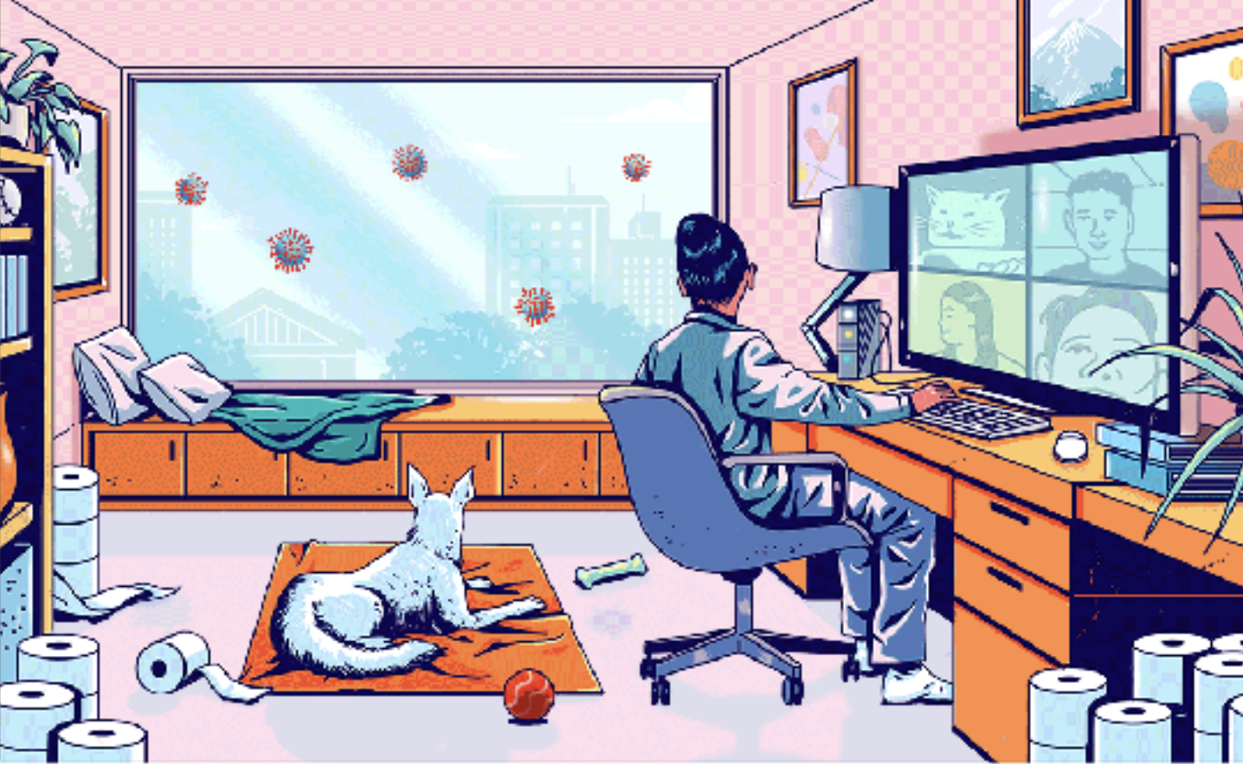

Connecting…

Life as we know it is talking to your friends and family through video chatting as the new normal. There is a deadly pandemic spreading throughout the world and people are panicking on stocking up on toilet paper. All I have been hearing is “I thought it was a virus with symptoms of a cold not diarrhea.” Covid-19 has taken over our lives, it is all we hear and see. Wearing a mask and gloves is the new normal now, as well as staying six feet apart. It is nice just having to wake up and going to class in pajamas, but I am getting tired of just being locked in home all day. I feel like this virus has eyes and is just staring at me through a window waiting to be let in. It gets a little boring everyday but without technology I honestly do not know what we would all do. All we can do is just stay home hoping this pandemic starts to get controlled so we can all try to go back to a normal life.

Virus Who?

I truly do believe that laughter is the best medicine. Memes, a picture with a funny text that goes with it, have taken over the internet for a couple of years now. This generation is able to make memes from a kid show like SpongeBob to something a little more serious like the Coronavirus. I truly do believe that laughter is the best medicine.When I feel sad, I often go to Twitter to read funny tweets and memes. It makes me forget about being sad especially during a hard time where we are all on lock down. While we are all still in quarantine my most used apps are TikTok and twitter. During these hard times I often go to TikTok to laugh at funny videos and a lot of them have to do with the virus. I can go through a lot of videos for hours and I feel like it has helped a lot to make the days go by faster. It is the same with Twitter, people as they like to say, “have no chill.” They post very relatable tweets with memes along with funny memes making fun of the virus. I do not think laughing about the virus is necessarily such a bad thing, I feel like you are supposed to have a little laughter in your life to brighten your day to still feel sane. I understand that some people may get offended by some memes, but I feel like they should understand that we are just trying to get though our day. Even if it means that memes are the one that help us.

Haiku

The Waiting Game

We’re still in the house
The virus is just starring
Waiting to come in

#Chaos

Chaos all around
Supplies very limited
What is going on?

Looking Ruff

Waking up for class
Three minutes before it starts
Looking like a bum

