Life of a Journal
Valerie Garcia

In the journal I do not just express myself more openly than I could to any person; I create myself. The journal is a vehicle for my sense of selfhood. It represents me as emotionally and spiritually independent. Therefore (alas) it does not simply record my actual, daily life but rather—in many cases—offers an alternative to it. —Susan Sontag, Reborn: Journals and Notebooks, 1947-1963

This quote has a meaning to my personal life because it says she expresses herself emotionally and spiritually. I have a journal myself and every time I feel like I cannot speak to anyone I grab my journal and write all my emotions out. Having a journal helps me free my mind. I can be myself when I write in my journal without being judged. Writing in a journal isn't just about your life, but it is so much more. This quote touched me because I can actually relate to it when I had a hard time in high school. I never really liked opening up to anybody so I opened myself up to my journal. Writing what is on my mind all the time helps me mentally and emotionally.

Social Distancing

Social distancing means having to be apart from other people. Having to be social with friends and family in a large space apart from one another. My family and I are currently staying home trying our best not to go out. Having to do important errands is the only time we step away from our house. We do not communicate with anyone unless it is with FaceTime or Zoom. It is better for us to not have any risks. If we have any celebration to attend we do it in the car, by passing by and honking. The biggest challenge we have is connecting with our family members. We do not want to risk any chances of having people over. We recently have not had any unexpected joy. Hopefully something joyful does appear along the way. I believe that this is more difficult for my family and I because we can not see anyone or actually get things done. People do not feel safe to go out anymore. Some people are paranoid about this situation and some have actually not truly cared. It’s hard for people to live their life like normal in a way where they will not be traumatized about the viruses as long as they do not have fresh air and use masks everywhere they go.

All for Me

I would actually love to have Disneyland to myself with no lines. The reason I decided to choose Disneyland is because I've never actually gone to Disneyland. I want to go on all the rides at Disneyland. It would be great to have no lines for rides because I would enjoy it more. I would take lots of pictures with Mickey Mouse, Goofy, and all the princesses. It would be a great time to actually go with my family and friends. I have always wanted to have Disneyland by myself since I was a little kid. It was always a great dream.

Music

Playing music helps me keep calm. During these times it’s hard for me to actually get my mind off of feeling sick. I actually try my best to get my mind off of something, especially something really difficult. Having to actually spend time with someone or hear music can be a great feeling. I listen to all types of music to make myself feel comfortable. I like to listen to music in any type of mood that I am in. Sometimes it makes me feel soothing. At the beginning of the quarantine I didn’t really listen to my music. One thing I actually did was listen to music before I go to sleep. It helps me relax. Meditation music was a better way to sleep in the thought of the virus. Hearing music can help me get my mind off of any problems that I have in my life.

LIFE AS WE KNOW IT?

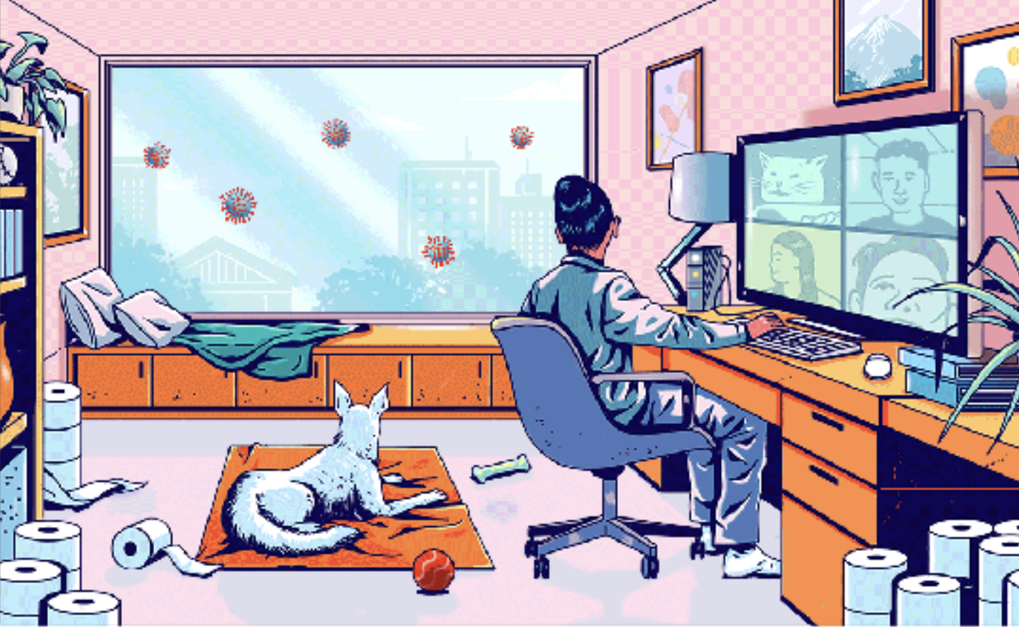

Life as we know it is giving us hard times. Having to be stuck in the house has shown us that outside it's really difficult with Covid-19. This also shows us that we have to be safe and cautious about our surroundings while we go outside. This has shown us how people have been stacking up with needs as in toilet paper, food, etc… Life as we know it is also showing us that having to be around people isn't a safe move either. People have been communicating with one another through Facetime Or Zoom. Many students have class during this situation. People want to hang out with friends, but they have been making Facetimes which helps them communicate with others. Not many people are able to go out; some cities have already opened their stores. I'm pretty sure nothing will ever be the same. This picture shows how people have been for the past weeks being in quarantine. I can relate to this imagine because I have been staying inside doors. Being outside makes me feel like I can't even get any fresh air. This is happening in many places and hopefully things can get back to normal. Life as we know it comes with many challenges, and this is one of the challenges that it has given us.

Ha! Ha!

In my own experience, laughter is a better medicine because it brings joy. Feeling positive is stress relief. Laughing at these difficult moments for me is relaxation, also having some energy and vibing is actually a role in my situation right now. I have joy around my family. We have some funny moments at home, but also some games we play all together as a family is pretty great and joyful. Getting a lot of things done together is also nice because it feels like everyone is just there for each other and that’s how it’s supposed to be in these situations. I actually do see some jokes about Covid-19 and some I do not find funny because many people who actually have it are dying. Many people are not taking this virus so seriously, but actually having the smallest symptoms in your body can actually be Covid-19. I do not think people should make jokes because it’s the hardest time a family can ever have, even if it’s not their own family suffering, it can be a really difficult situation. This is my opinion about jokes; we should know when to actually laugh in the right moments and then not laugh at things that should not be joked about. I just believe there are other things they can joke about other than having to joke about something serious.

Poems

Safety

Step outside - not safe.
Life as we know it shows more
damage than in a cage.

Can’t find comfort

But still have some faith.
Show the world your capable.
Freedom awaits - be safe.

Distance

I stand 6 feet away,
making sure no one is direct.
I am patient to wait for the best.
Breathing some air
just makes sure it's not theirs

Together

We are distant, but we got each other.
One can stop the virus alive.
One can stop the spread, just stay inside.
Don't be selfish just be clean together
We can defeat this huge enemy.

